Lunar Calendar
# Source: AI Source: Provided by: [Data Path: Persons Table -> ID Column: 1, Name_En Column: Motasem Essam] -> From: [ChatGPT] on [7/17/2026]
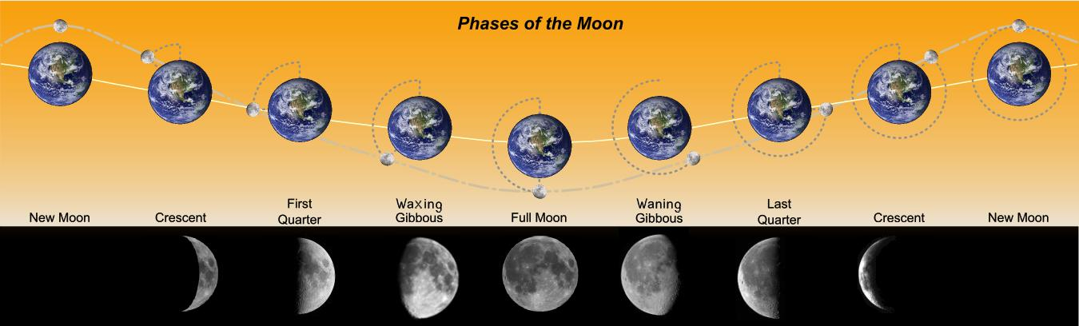
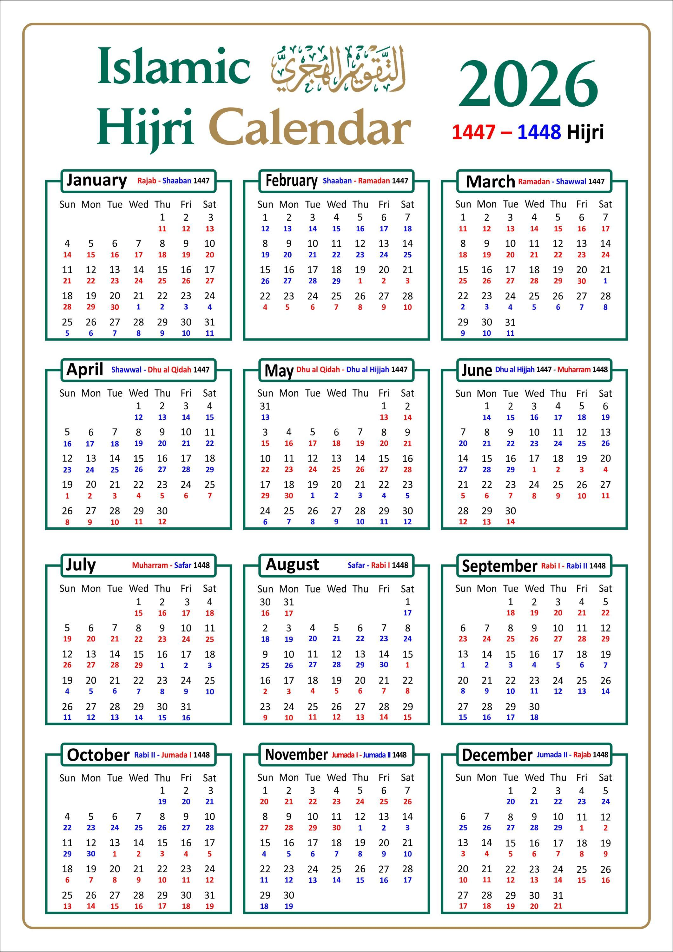
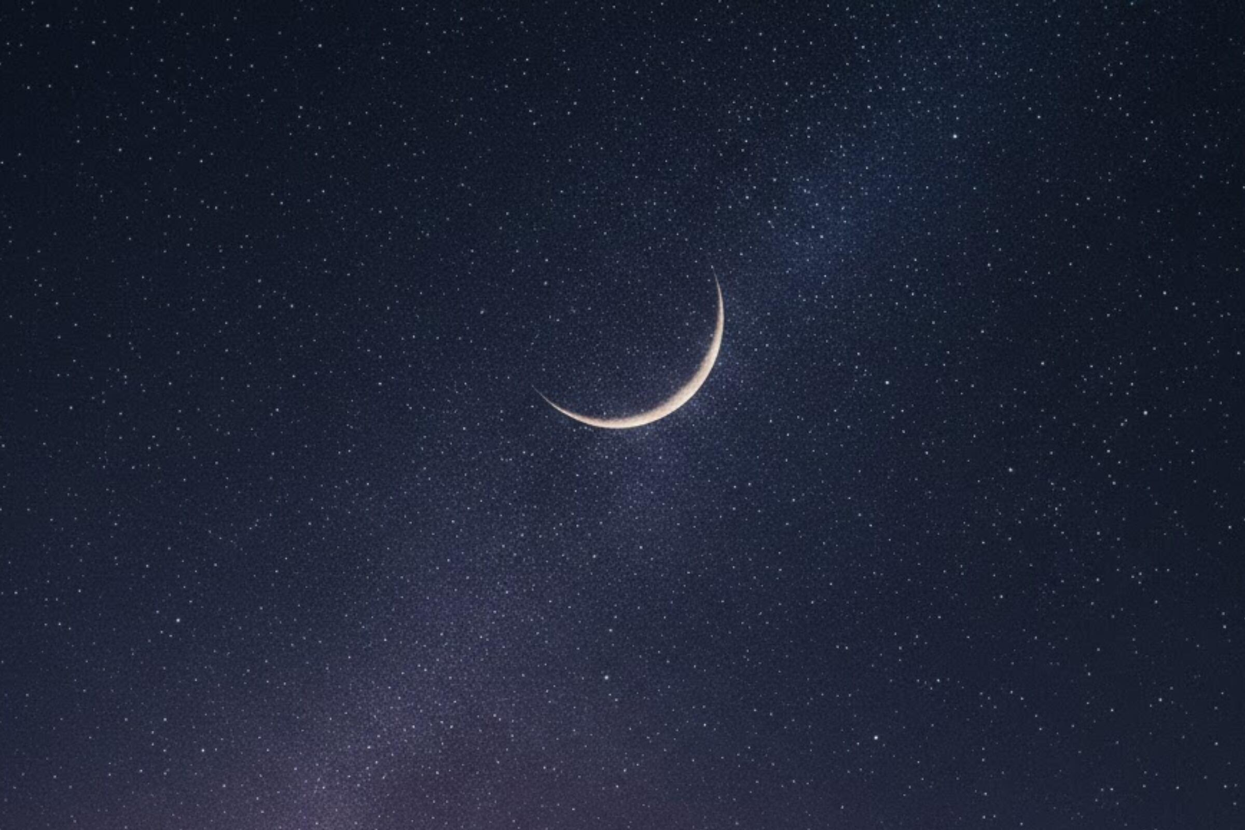
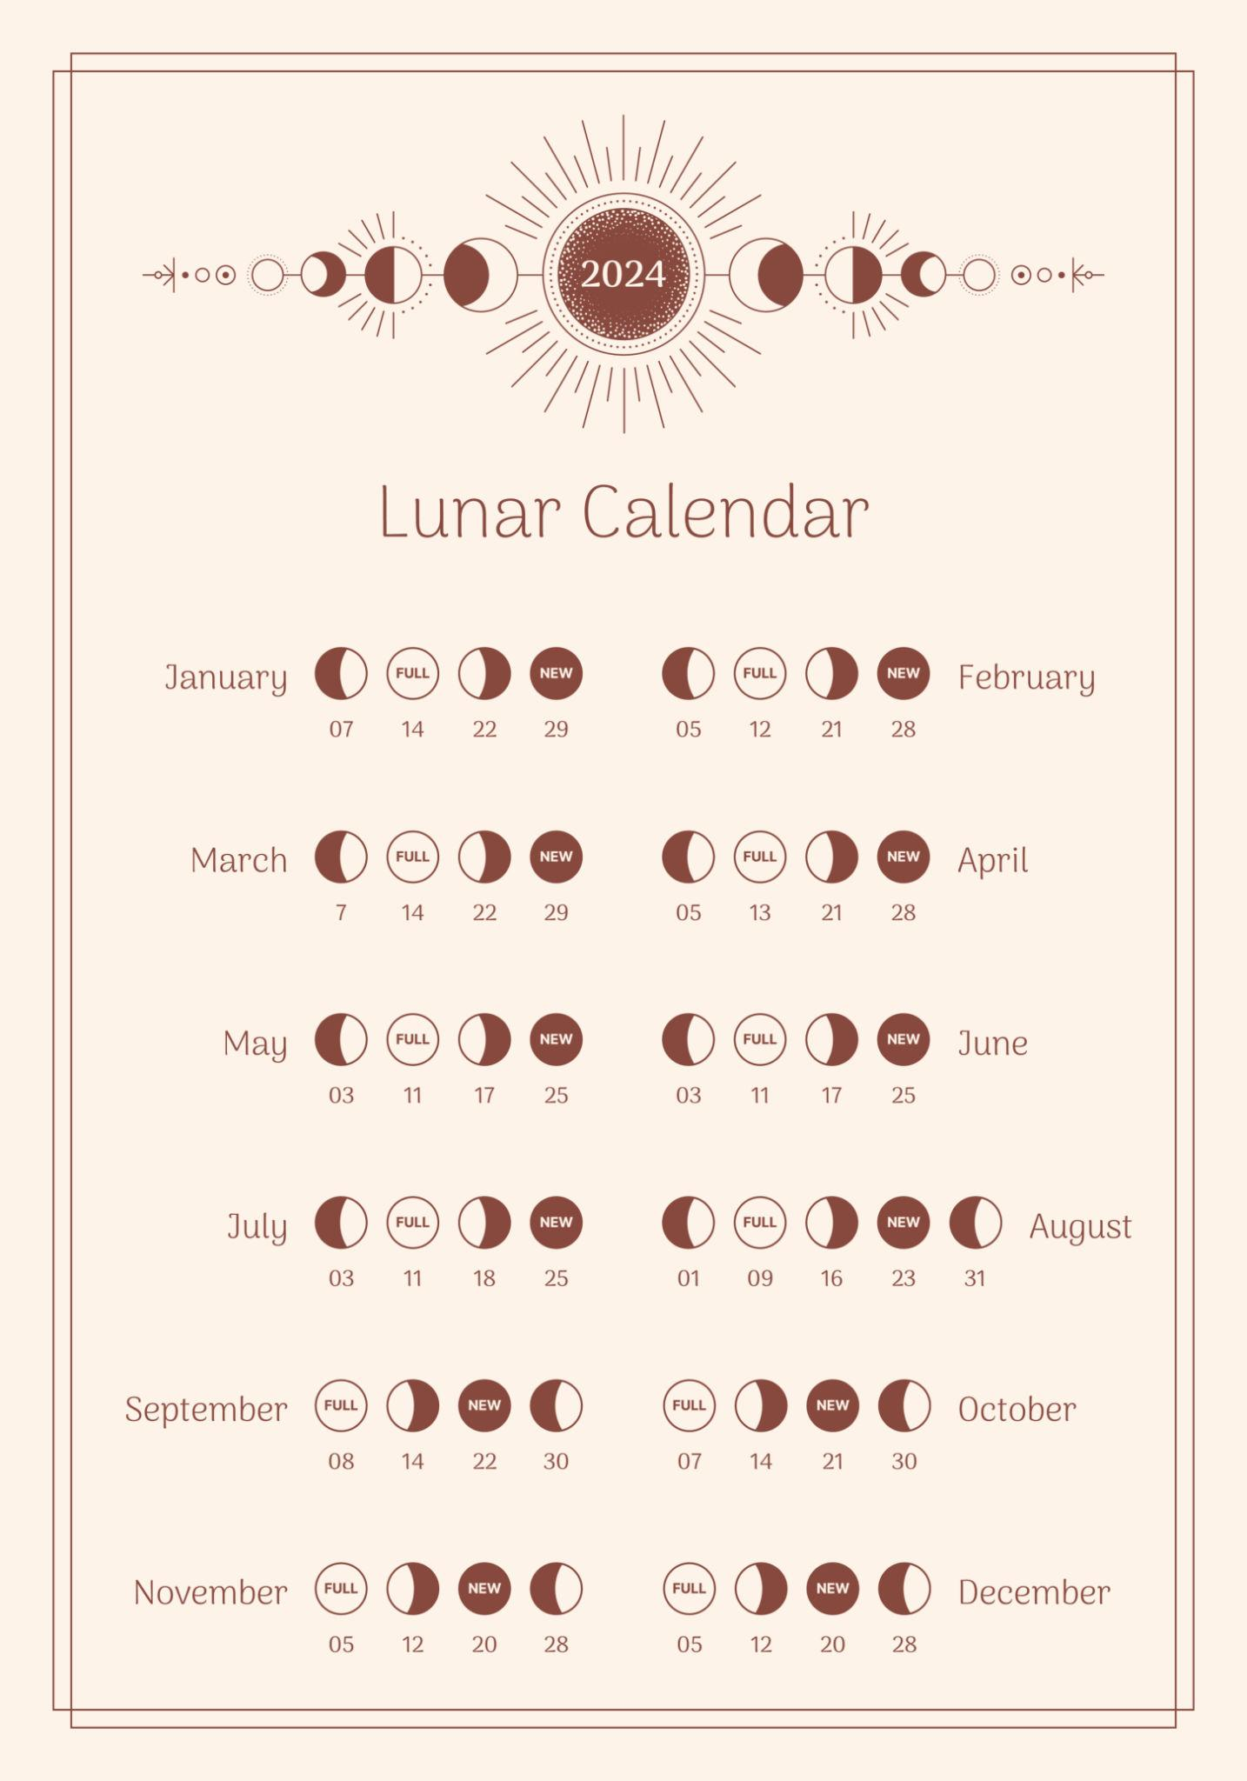
A Lunar Calendar is a calendar system based on the phases of the Moon. In a lunar calendar, each month begins with a new lunar cycle, and the year is made up of 12 lunar months.
Unlike a solar calendar, a lunar calendar does not remain synchronized with the Earth's seasons because its year is approximately 11 days shorter than a solar year.
The best-known example of a lunar calendar is the Islamic (Hijri) Calendar.

Definition
# Source: AI Source: Provided by: [Data Path: Persons Table -> ID Column: 1, Name_En Column: Motasem Essam] -> From: [ChatGPT] on [7/17/2026]
A Lunar Calendar is a calendar system in which months are determined by the Moon's phases, and the year consists of twelve lunar months.

Purpose
# Source: AI Source: Provided by: [Data Path: Persons Table -> ID Column: 1, Name_En Column: Motasem Essam] -> From: [ChatGPT] on [7/17/2026]
A lunar calendar is used to:
- Measure time using the Moon's cycles.
- Determine religious observances.
- Schedule traditional festivals.
- Record historical dates.
- Organize cultural events.

Astronomical Basis
# Source: AI Source: Provided by: [Data Path: Persons Table -> ID Column: 1, Name_En Column: Motasem Essam] -> From: [ChatGPT] on [7/17/2026]
A lunar calendar is based on the synodic month, which is the time between two successive new moons.
Average length of one lunar month:
$$29.5306\text{ days}$$
A lunar year consists of:
$$12×29.5306≈354.37\text{ days}$$

Main Characteristics
# Source: AI Source: Provided by: [Data Path: Persons Table -> ID Column: 1, Name_En Column: Motasem Essam] -> From: [ChatGPT] on [7/17/2026]
A lunar calendar typically has:
- 12 lunar months
- 354 or 355 days per year
- Months of 29 or 30 days
- No natural alignment with the seasons

Components
# Source: AI Source: Provided by: [Data Path: Persons Table -> ID Column: 1, Name_En Column: Motasem Essam] -> From: [ChatGPT] on [7/17/2026]
A lunar calendar consists of:
- Day
- Week
- Lunar month
- Lunar year
Each new month traditionally begins with the observation (or accepted calculation) of the new crescent moon.

Relationship to the Seasons
# Source: AI Source: Provided by: [Data Path: Persons Table -> ID Column: 1, Name_En Column: Motasem Essam] -> From: [ChatGPT] on [7/17/2026]
Because a lunar year is about 11 days shorter than a solar year:
- The months gradually move through all seasons.
- Festivals occur earlier each solar year.
- After about 33 years, the lunar calendar completes a full cycle through the seasons.

Examples of Lunar Calendars

1. Islamic (Hijri) Calendar
# Source: AI Source: Provided by: [Data Path: Persons Table -> ID Column: 1, Name_En Column: Motasem Essam] -> From: [ChatGPT] on [7/17/2026]
Characteristics
- Pure lunar calendar
- 12 lunar months
- 354 or 355 days
- Used to determine:
  - Ramadan
  - Eid al-Fitr
  - Eid al-Adha
  - Hajj

Length of the Year
# Source: AI Source: Provided by: [Data Path: Persons Table -> ID Column: 1, Name_En Column: Motasem Essam] -> From: [ChatGPT] on [7/17/2026]
A common lunar year contains:
- 354 days
A leap lunar year contains:
- 355 days
Average:
$$\boxed{354.37\text{ days}}$$

Length of the Month
# Source: AI Source: Provided by: [Data Path: Persons Table -> ID Column: 1, Name_En Column: Motasem Essam] -> From: [ChatGPT] on [7/17/2026]
Each month contains either:
- 29 days
- 30 days
Average:
$$\boxed{29.53\text{ days}}$$

Month Determination
# Source: AI Source: Provided by: [Data Path: Persons Table -> ID Column: 1, Name_En Column: Motasem Essam] -> From: [ChatGPT] on [7/17/2026]
The beginning of each month is traditionally determined by:
- Sighting the new crescent moon
Some modern communities use:
- Astronomical calculations

Advantages
# Source: AI Source: Provided by: [Data Path: Persons Table -> ID Column: 1, Name_En Column: Motasem Essam] -> From: [ChatGPT] on [7/17/2026]
A lunar calendar:
- Closely follows the Moon's natural phases.
- Is simple to understand.
- Supports religious observances tied to lunar cycles.
- Preserves cultural traditions.

Limitations
# Source: AI Source: Provided by: [Data Path: Persons Table -> ID Column: 1, Name_En Column: Motasem Essam] -> From: [ChatGPT] on [7/17/2026]
A lunar calendar:
- Does not stay synchronized with the seasons.
- Agricultural events gradually shift through the year.
- Festivals occur on different Gregorian dates each year.
- Requires moon observation or accepted astronomical calculations.

Applications
# Source: AI Source: Provided by: [Data Path: Persons Table -> ID Column: 1, Name_En Column: Motasem Essam] -> From: [ChatGPT] on [7/17/2026]
Lunar calendars are used in:
- Religious observances
- Cultural traditions
- Historical studies
- Festival scheduling
- Traditional ceremonies

Comparison with Other Calendar Systems
# Source: AI Source: Provided by: [Data Path: Persons Table -> ID Column: 1, Name_En Column: Motasem Essam] -> From: [ChatGPT] on [7/17/2026]
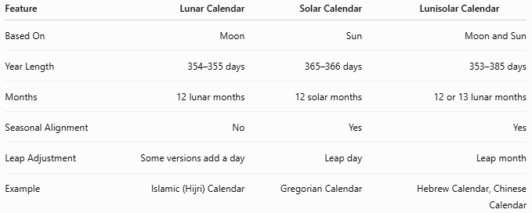
Feature | Lunar Calendar | Solar Calendar | Lunisolar Calendar
Based On | Moon | Sun | Moon and Sun
Year Length | 354–355 days | 365–366 days | 353–385 days
Months | 12 lunar months | 12 solar months | 12 or 13 lunar months
Seasonal Alignment | No | Yes | Yes
Leap Adjustment | Some versions add a day | Leap day | Leap month
Example | Islamic (Hijri) Calendar | Gregorian Calendar | Hebrew Calendar, Chinese Calendar

Common Mistakes
# Source: AI Source: Provided by: [Data Path: Persons Table -> ID Column: 1, Name_En Column: Motasem Essam] -> From: [ChatGPT] on [7/17/2026]
- Confusing a lunar calendar with a lunisolar calendar.
- Assuming lunar months always have exactly 30 days.
- Expecting lunar holidays to occur on the same Gregorian date every year.
- Assuming lunar calendars remain aligned with the seasons.

Key Points
# Source: AI Source: Provided by: [Data Path: Persons Table -> ID Column: 1, Name_En Column: Motasem Essam] -> From: [ChatGPT] on [7/17/2026]
- A Lunar Calendar is based on the Moon's phases.
- One lunar month averages:
$$29.5306\text{ days}$$
- One lunar year averages:
$$354.37\text{ days}$$
- A lunar year is approximately 11 days shorter than a solar year.
- Lunar calendars are not synchronized with the seasons.
- The Islamic (Hijri) Calendar is the most widely used example of a pure lunar calendar.

Conclusion
# Source: AI Source: Provided by: [Data Path: Persons Table -> ID Column: 1, Name_En Column: Motasem Essam] -> From: [ChatGPT] on [7/17/2026]
A Lunar Calendar measures time according to the recurring phases of the Moon, with twelve lunar months forming a year of approximately 354 or 355 days. Because this is shorter than the Earth's solar year, lunar months and the festivals based on them gradually shift through the seasons over time. While this makes lunar calendars less suitable for agricultural and civil planning, they remain essential for religious observances, cultural traditions, and historical continuity, with the Islamic (Hijri) Calendar being the most prominent example in use today.

